# Media Analysis - Will ChatGPT and AI have an impact on Saudi workforce productivity

## Short Summary

The article highlights how ChatGPT and other AI technologies can enhance Saudi Arabia's workforce productivity through customized training, collaboration tools, and personalized services across sectors like healthcare, transportation, energy, finance, and retail. Simultaneously, it acknowledges the risk of job displacement due to automation, advocating for a strategic approach in AI integration that aligns with organizational goals and cultivates an enabling learning environment.

## Summary

1. **AI Technologies Boost Productivity**: ChatGPT and other artificial intelligence platforms are creating a wave of change in the global workforce, serving as a useful tool for Saudi Arabia's personnel to boost economic development by enhancing productivity. 2. **Alleviating Employee Fears**: Despite concerns about AI replacing manpower with robots and software, experts like Raymond Khoury at Arthur D. Little have alleviated these fears by emphasizing the potential benefits of embracing innovation through AI. 3. **Nurturing Talent with AI Culture**: Implementing AI technologies requires a strong human dimension to successfully embed it into operations, promoting an AI culture that encourages experimentation, learning, and collaboration among employees. 4. **AI Impact on Career-Related Skills**: ChatGPT can positively impact various aspects of career-related skills in talent management, including recruitment, training, upskilling, reskilling, talent collaboration, and knowledge management. 5. **Enhancing Employee Productivity**: AI, specifically ChatGPT, can provide tailor-made training programs for employees, access to customized online courses, and foster team collaboration, leading to increased productivity within organizations due to less time spent on mundane tasks. 6. **AI Impact Across Sectors**: The impact of AI will extend across sectors like public sector, healthcare, transportation, energy, finance, and retail in Saudi Arabia, offering opportunities for more efficient operations, better service delivery, and growth. 7. **Potential Risks**: While AI offers numerous benefits, it also presents risks such as job displacement due to automation of repetitive tasks, potentially threatening employee stability. To mitigate this, workers need to acquire new skills through retraining or upskilling to remain marketable in the evolving digital world. 8. **Strategic Approach**: Embedding AI into organizations' operations requires a holistic approach that clearly defines strategic objectives, advantages, and disadvantages. This involves understanding operational bottlenecks, selecting appropriate AI tools or technologies, and fostering an environment of learning and improvement to ensure success in the rapidly changing technological landscape. 9. **Leadership and Agility**: Implementing AI necessitates solid leadership, a forward-thinking perspective, agility in making timely changes, and proactive adaptation as needed by the organization. 10. **Positive Employee and Client Experience**: To successfully integrate AI into organizations' operations, it's crucial to foster an optimistic environment that encourages employee learning and client interaction improvement.

## Question 1:

How do the media in this article frame the public discussion about ChatGPT? Are there certain **metaphors** that keep cropping up?

In this article, the media frames the public discussion about ChatGPT primarily by portraying it as a transformative force driving productivity and economic development in Saudi Arabia. The metaphors used to describe AI and its impact are 1. **Wave of Change** This framing emphasizes that AI, including ChatGPT, is ushering in significant shifts and transformations within the workforce. 2. **Useful Tool for Economic Development** The article highlights how AI can be leveraged to boost economic growth by enhancing productivity e.g.,

## Question 2:

Which role does or might the Arabic World play in the development of Artificial Intelligence? Answer with 'Not mentioned' if not applicable.

Not mentioned

## Question 3:

Which use cases of Artificial Intelligence are helpful for the Arabic world based on this article?

ChatGPT and other AI platforms like ChatGPT have the potential to significantly enhance productivity within Saudi Arabian companies. By automating repetitive tasks, they enable employees to focus more on strategic activities. This can be seen in areas such as recruitment, training, upskilling, reskilling, and knowledge management where ChatGPT provides personalized training programs and fosters collaboration among team members.

## Question 4:

What is the final message of the article that the author wants to convey? Keep your answer short and precise!

The final message is a balanced view emphasizing the potential benefits of AI integration for productivity enhancement, while also acknowledging the need for proactive adaptation and skill development from both organizations and employees.

## Sentiment

The sentiment is <0>

0

## Entities

Raymond Khoury, Foster Collaboration Communication Team, Chatgpt Ai, Arthur Littlehe Add Ai, Chatgpt Ai Impact Saudi Workforce, Task Automate, Flip Khoury, Embed Ai Operation Saudi Company Employee Require Holistic Approach Clearly Define Strategic Objective Advantage Disadvantage Kaspersky Survey Support, Arthur, Cairo Chatgpt Artificial Intelligence Platform Create Wave Change Global Workforce Turn Useful Tool Saudi Arabia Personnel Boost Economic Development Ai Raise Concern, Khoury, Regard Energy Sector Innovative Technology

## Topic Clusters

### Cluster: Artificial Intelligence Technologies

AI technologies, ChatGPT

### Cluster: Productivity Boost

productivity boost

### Cluster: Advantages Identification

identification of advantages

### Cluster: Disadvantages Assessment

disadvantages assessment

## Word Clouds

### Wordcloud of content

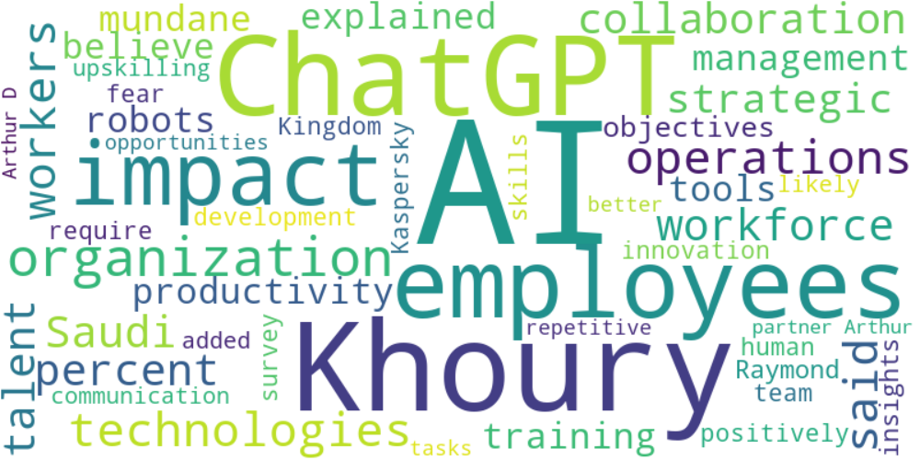

Top 10 words:

- AI: 34  
- Khoury: 15  
- ChatGPT: 12  
- employees: 11  
- impact: 9  
- technologies: 6  
- operations: 6  
- said: 6  
- workers: 6  
- Saudi: 5

### Wordcloud of summary

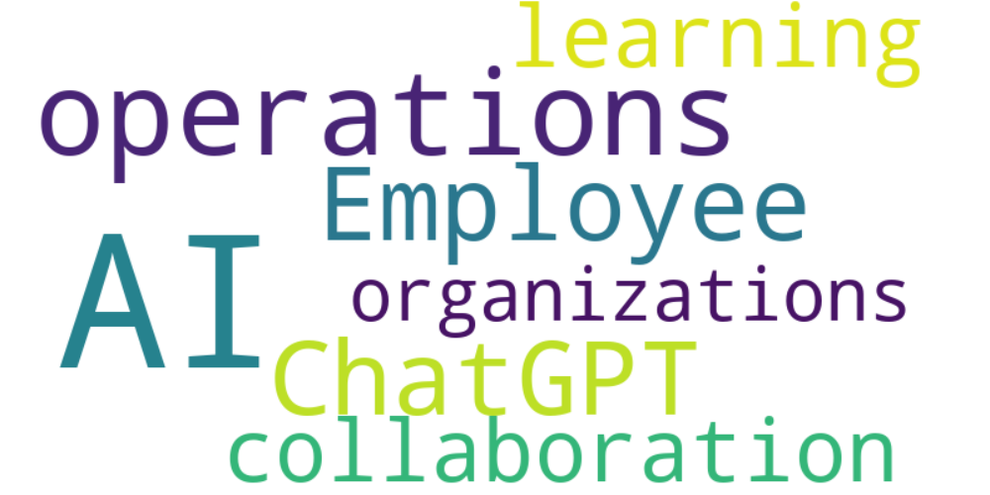

Top 10 words:

- AI: 15  
- operations: 4  
- ChatGPT: 3  
- Employee: 3  
- learning: 3  
- collaboration: 3  
- organizations: 3